**EXP18: DEMONSTRATE INFRASTRUCTURE AS A SERVICE (IAAS) BY CREATING A VIRTUAL MACHINE USING A PUBLIC CLOUD SERVICE PROVIDER (AZURE), CONFIGURE WITH REQUIRED MEMORY AND CPU.**

**AIM:**

To demonstrate infrastructure as a service (iaas) by creating a virtual machine using a

public cloud service provider (azure), configure with required memory and cpu.

**PROCEDURE:**

STEP1: CREATE AN ACCOUNT IN MICROSOFT AZURE.

STEP2: GOTO RESOURCE GROUPAND CREATE A RESOURCE GROUP.

STEP3: GIVE NECESSARY THINGS FOR RESOURCE GROUP.

STEP4: CREATE AVIRTUAL NETWORK FOR TO CREATE AVIRTUALMACHINE .

STEP5: NOW CREATE A VIRTUAL MACHINE WITH UR IPADDRESS ANUSERNAME AND

PASSWORD FOR YOUR VIRTUAL MACINE.

STEP6: AND YOUR VIRTUAL MACHINE IS DEPLOYED.

STEP7: NOW CONNECT THE VIRTUAL MACHINE AND DOWNLOAD THE RDP FILETO OPEN YOUR

WINDOWS VIRTUAL MACHINE.

STEP8: NOW RESIZE THE VIRTUAL MACHINE SIZE.

STEP9: CREATED ANEW WINDOWS VIRTUAL MACHINE

**IMPLEMENTATION:**

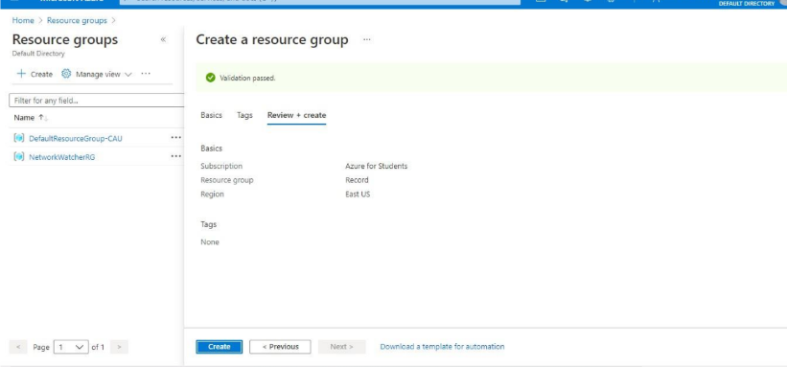

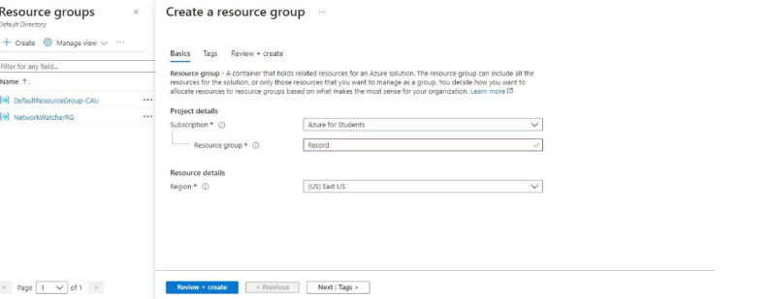

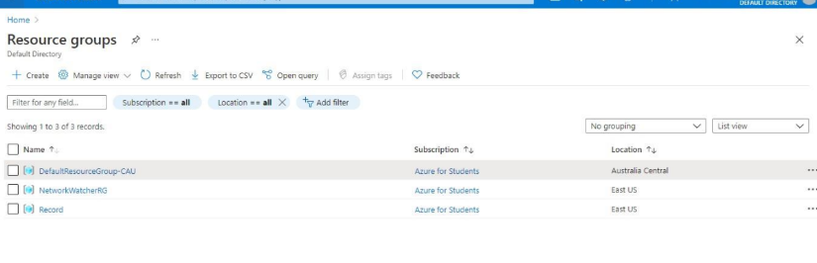

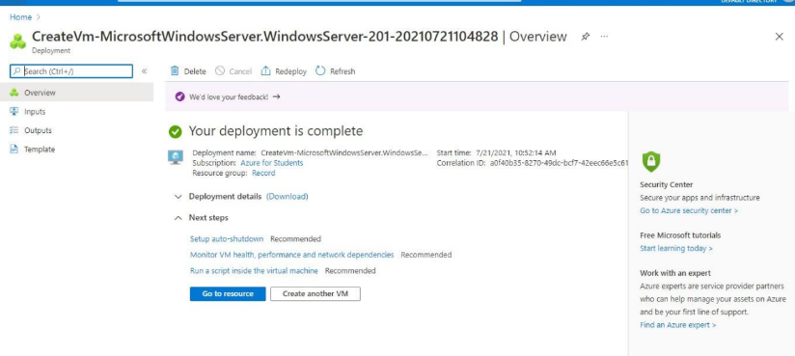

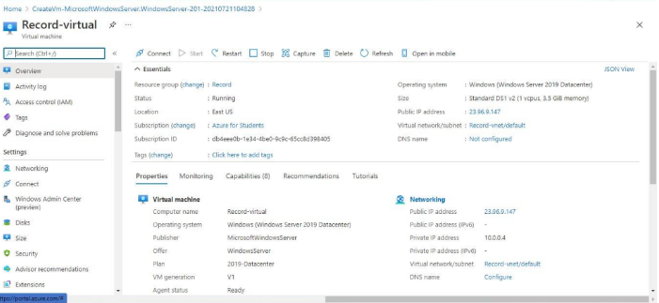

**RESULT:**

Infrastructure as a service (iaas) by creating a virtual machine using a

public cloud service provider (azure), configure with required memory and cpu has been demonstrated.